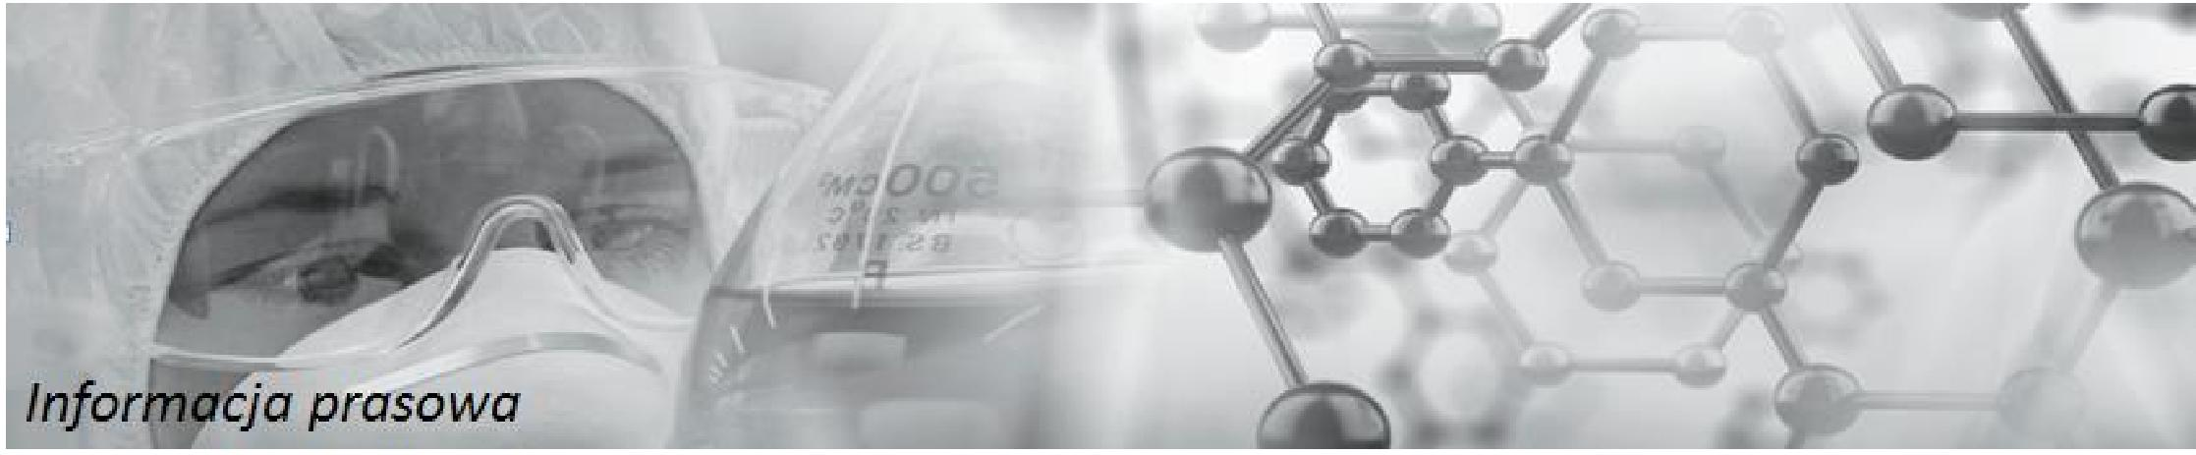
Warsaw, 5 January 2018
Completed administration of the Esketamine-based drug to all subjects of the first part of the phase 1 trial
Information received from the study centre confirms its course in accordance with the schedule and assumptions in terms of patient safety as defined in the clinical protocol approved by the Office for Registration of Medicinal Products, Medical Devices and Biocidal Products.
In the first part of the phase 1 trial were administered a drug dose provided for in the clinical protocol. An analysis of safety results and pharmacokinetic features will be used to select a drug administration regimen for the second part of the phase 1 trial.
Maciej Wieczorek, PhD, President of the Board of Celon Pharma S.A.: We will now be analysing data in order to establish the final drug administration regimen for the second part of the phase 1 trial. The course of the trial and patient follow-up reflect in full the assumptions
we adopted in the clinical protocol in terms of patient safety, as well as in the clinical programme schedule.
Celon Pharma S.A. is implementing the project on the use of inhaled Esketamine in treatment of drug-resistant depression. It covers phases 1 and 2 of clinical trials. Co-funding from the National Centre for Research and Development amounts to over PLN 12 million. Celon Pharma S.A. is the first Polish company which has the chance to market a new medicinal product for drug-resistant depression.
Ketamine is a substance known in medicine since the 1960s and used in anaesthesia and analgesia. More and more research results confirm the observation that the administration of an NMDA receptor antagonist – i.e. ketamine – reduces the severity of symptoms of the depressive syndrome. They also indicate that the use of ketamine reduces the symptoms of depression within hours of administration, unlike other drugs which start working after a few weeks of regular use. In the USA, although this drug is not registered as a drug for depression, in states where it is allowed, more and more doctors use ketamine to treat depression with encouraging effects.

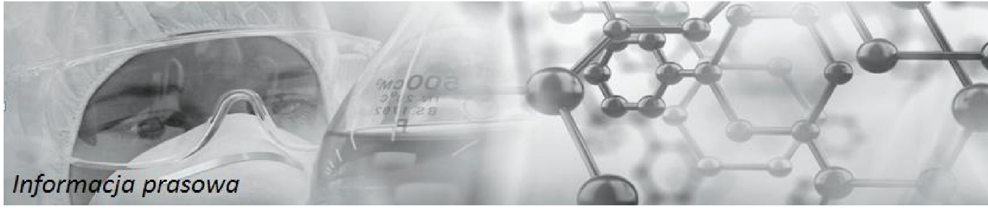
Warsaw, 5 January 2018
Celon Pharma S.A. is an integrated pharmaceutical company which conducts advanced research and manufactures modern drugs. It was founded in 2002 by Maciej Wieczorek, PHD. Celon Pharma S.A. has two fully equipped laboratories dedicated to research and development of medicinal products (R&D) for both generic and innovative drugs. Two of Celon Pharma S.A.'s production plants have appropriate GMP (Good Manufacturing Practice) authorisations. The main office and the laboratories are located within 30 km from the centre of Warsaw. The company currently has approx. 250 employees. It employs 62 scientists responsible for research and development, half of whom either have a PhD or are in the process of acquiring their PhD. The company operates more than a dozen projects for the development of innovative drugs with therapeutic groups such as oncology, neuro-psychiatry, autoimmunity and metabolism.

